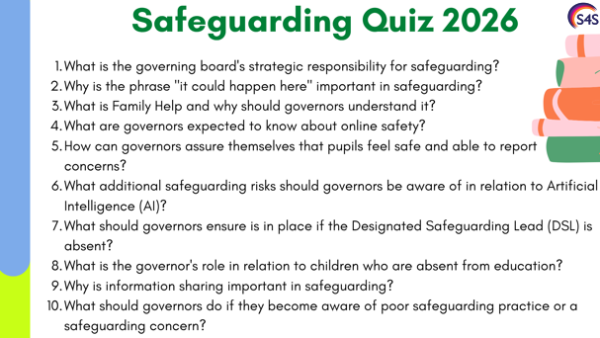

1.Answer: To ensure safeguarding arrangements are effective, comply with legislation, and that policies, procedures, systems and training are regularly reviewed and implemented effectively.

2. Answer: It encourages vigilance and professional curiosity, ensuring concerns are not dismissed and that staff remain alert to signs of abuse, neglect and exploitation.

3. Answer: Family Help replaces Early Help in KCSIE 2026 and focuses on providing support as soon as problems emerge. Governors should ensure staff understand local referral pathways and thresholds.

4. Answer: Governors should understand the school's approach to online safety, filtering and monitoring systems, annual reviews of their effectiveness, and how online risks are addressed through education and safeguarding policies.

5. Answer: Through pupil voice activities, safeguarding reports, surveys, learning walks and discussions with leaders about reporting systems and pupil experiences.

6. Answer: Risks include deepfakes, AI-generated harmful content, misinformation, online exploitation, and ensuring staff and pupils understand how to use AI safely and responsibly.

7. Answer: Robust cover arrangements, including trained deputy DSLs and systems to ensure safeguarding concerns are received, monitored and acted upon without delay.

8. Answer: To seek assurance that attendance concerns are monitored, acted upon promptly and recognised as potential indicators of safeguarding issues such as neglect, exploitation or abuse.

9. Answer: Timely information sharing helps identify risks, protect children and ensure they receive the right support. Data protection laws do not prevent information being shared to keep children safe.

10. Answer: Follow the school's safeguarding procedures, report concerns appropriately, challenge where necessary and ensure concerns are acted upon in the best interests of the child.

Bonus question
What is the most important principle underpinning all safeguarding decisions in KCSIE 2026?
Answer: The best interests of the child must always be at the heart of all systems, processes, policies and decisions.

