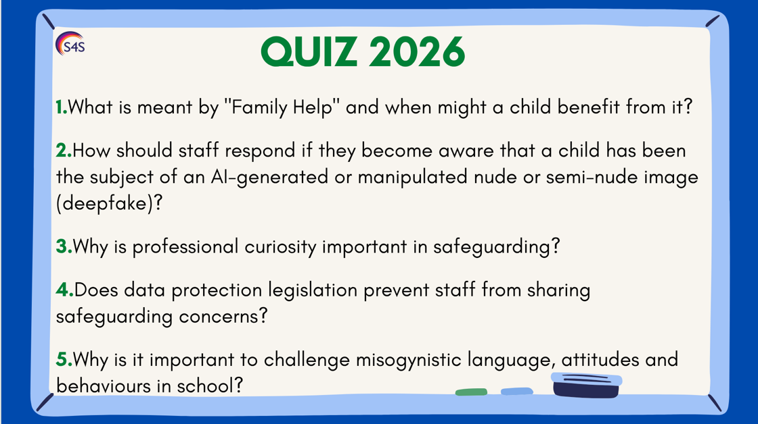

1. Answer: Family Help is support provided to children and families when needs emerge, before statutory intervention is required. Staff should be alert to early signs of vulnerability and report concerns so children can receive the right support at the right time.

2. Answer: Staff should:
- Treat the incident as a safeguarding concern and report it immediately to the Designated Safeguarding Lead (DSL).
- Reassure the child, listen carefully and avoid asking leading questions or viewing or sharing the image unless absolutely necessary.
- Never promise confidentiality and explain that the information will be shared with those who need to know to help keep the child safe.
- The DSL should assess the risk in line with KCSIE 2026 and the DfE guidance on Sharing nudes and semi-nudes: advice for education settings, considering the child's welfare, any criminal offences, online safety risks and whether referrals to the police, children's social care or other agencies are required.
- Provide ongoing support for the child, recognising the potential emotional, psychological and reputational impact of AI-generated or manipulated images, even where the image is not real.

3. Answer: Professional curiosity helps staff look beyond the presenting behaviour, ask appropriate questions and consider whether there may be underlying abuse, neglect, exploitation or unmet need. It supports early identification and intervention.

4. Answer: No. KCSIE 2026 makes clear that data protection is not a barrier to sharing information where it is necessary to safeguard and promote the welfare of children. Concerns should be shared promptly with the appropriate people.

5. Answer: Misogynistic attitudes can contribute to harmful behaviours, sexual harassment and violence against women and girls. Schools have a responsibility to promote respectful relationships, challenge harmful attitudes and create a safe culture for all pupils.

